A Menu of Ideas for Adults to Help Kids Stay Happy & Healthy during COVID 19
Good for All Ages
  Set Schedules  Make a schedule. Routine helps kids feel calm because they know what to expect. Involve your kids! See samples:  PK - 5th Grade  Middle & High School | Timely Talk    Talk to your children about COVID-19 using age-appropriate language. Listen and encourage them to ask questions.  Links to help:  Spanish English |   Move It!  Whether it’s taking a walk, going for a bike ride, breathing together, or having a dance party in the living room, we all need to move it! Join your child to exercise, do a Go Noodle, or even make a TikTok! |   Staying Calm  Sometimes Home Learning won’t go as planned. When something unexpected happens, stay calm. Turn Down the Heat in your home by using these simple steps when you feel angry. | Share your Rose Thorn Bud  Check in with your child.    A Rose (best part of day)  Thorn (not good part of day)  Bud (something you are looking forward to)
Write a caring letter or email to an elderly person who may be alone and deliver or mail it!   |   Play “Hot and Cold!” How? One person hides an object somewhere in your home and the others try to look for it. The hider can give clues like “warmer” when you get close or “look where the dog likes to sit” |   Breathe  Find your calm using these free links:  Headspace Calm  GoNoodle Smiling Mind  Mind Yeti: English | Spanish  Mind Yeti: English | Spanish | Staying Positive    Use these Positivity Google slides to listen to the book Ish and talk to your child about the power of being positive and believing in yourself. |   Self Care  Take care of yourself so you can be a role model for your kids. It can be hard to do, but try to sleep, take breaks, eat healthy foods, get outside and let them know things will be okay.
Online Support  Visit Brain Pop- SEL Learning through your my.bvsd.org account.    This home learning link provides guidance for before, during and after watching videos.  **Spanish options also available (K-8) | Play “Build It!”  Think of something you can build together from items around the house. Maybe it’s a maze, a tower, or a fort...be creative!   | Spread Positivity    Create notes with positive messages on them and tuck the notes around your neighborhood. | Getting Creative  Make Playdough with your child or your siblings - create figures to give to your neighbors, leaving a surprise by their front door.    Recipe w/video  Español w/video  Gluten Free recipe | Gratitude  In tricky times, it helps to focus on gratitude.  This folder contains many options for journaling about gratitude  
PK - 5 Students  |  |  | Tweens & Teens 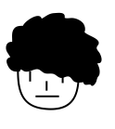
Tune Into Your Body    Do a Body Scan. Here’s a link to the steps | Listening & Learning    Together listen to a song, book or lesson from the We Do Listen Foundation  Topics include making the most of things, following screen time rules, fear and courage...and more! | 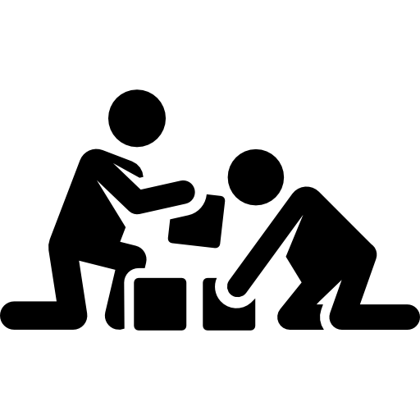  Play!  Game Time! Play Charades or go on a Scavenger Hunt  Like these? Find more at  My Kids For Peace Activities from Random Acts of Kindness | Listening & Learning  Tune your teen into a Ted Talk.  These are Ted Talks for teens recommended by teens. | Checking In  While they may show anxiety in different ways, older children need help handling change too. Talk to your teen about their feelings. Check out the videos on parentteenconnect.org for support!
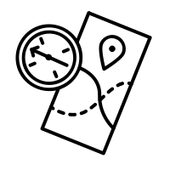  Go on a Safari!  Take a walk to find as many birds, bugs, leaves, and other special treasures as you can. Wrap a piece of tape (sticky side up) around your child’s wrist so they can stick their non-living treasures to it. Talk about it! | Current Events  Read this simple picture story about COVID 19 and help your child write their own.   |   Current Events  Watch the cartoon Covid 19 video and talk about feelings, fears, and questions your child may have.  Spanish Video |   Let it Out!  Crumble it Up! Have your teen write down something they are worried about, regret, or are generally bummed about on a scrap piece of paper. Then crumble up your worries and talk about it if you are ready. | Life Skills    Teach some “Adulting” skills. Teach your teen to cook dinner? Work on the truck with you? Help you file your taxes?  Use this time to teach some life skills you need to get done anyway.
  Empowering Kids  Create an entry for the “I am Powerful” Kids for Peace Book Contest. This will be our 5th book. Learn more: Flier & Book Entry Form | Slides for learning  Use these SEL Learning at Home slides for two weeks worth of guided activities- Do a few slides a day! | Listening & Learning  Listen to the Imagine Neighborhood podcast, a podcast where fun characters talk about how to handle big feelings. | Just Breathe  Your tween or teen needs to breathe, especially if they are taking on extra responsibilities to make this new normal work for your family. Invite your teen to lie down and try this Mindfulness track for teens. | Help Others  Teens can do so much! Challenge them to help the community in a creative way during COVID 19.    See how two teens in Arvada started a website for families to help each other.
Checking In  Encourage your kids to talk about their feelings. Children may be experiencing feelings of disappointment.  Watch and talk about this video! | Just for Fun  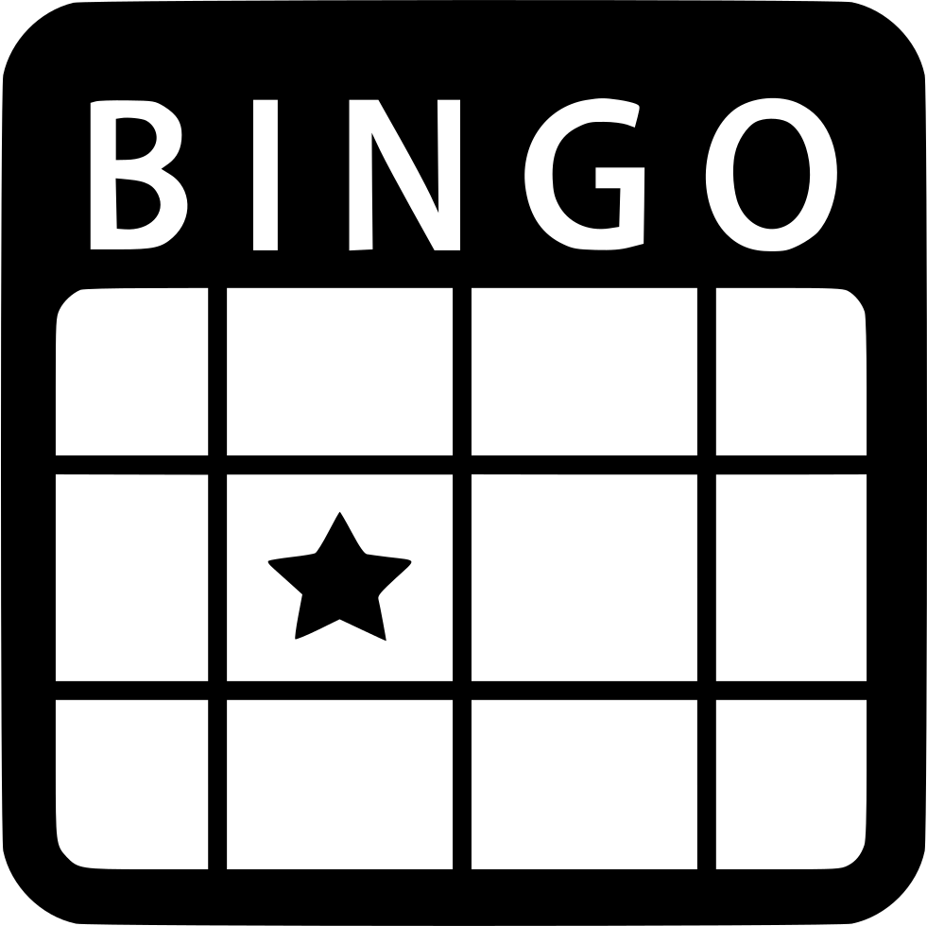  Try this BINGO game for fun! | Mindset is Powerful    Your mindset can change everything!  Watch this Video about mindset and complete the Activity together. | Connect!    Friends mean so much to your child, and Snapchat streaks won’t replace school.  Schedule time for a live chat with friends or family. | Staying Healthy  Get your teen out of bed!    A regular schedule of healthy meals, school time, exercise, and free time will help the whole family.

